TASK 1:
1.1
Write a Python Program to implement your own myreduce() function which works exactly like Python’s built-in reduce().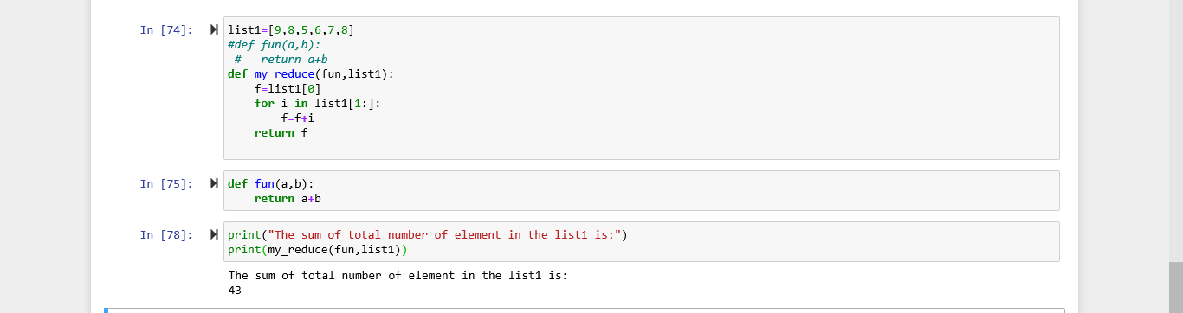

1.2
Write a Python Program to implement your own myfilter() function which works exactly like python built-in filter().
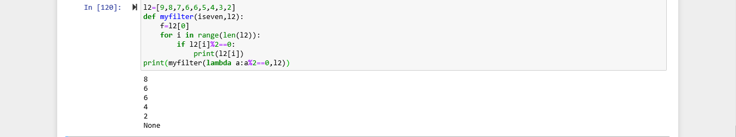
2.
Implement List compression to product the following lists.
Write List comprehension to product the following List.

[‘A’,’C’,’A’,’D’,’G,’I’,’L’,’D’]
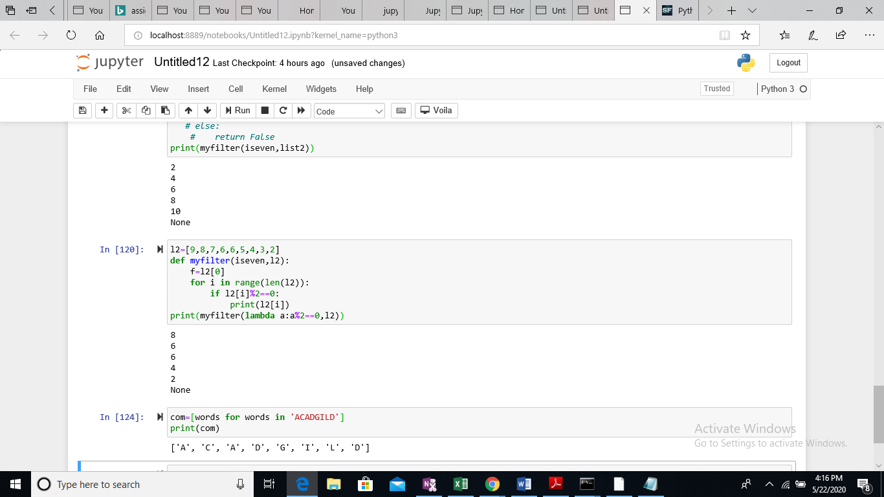
[‘x’,’xx’,’xxx’,’xxxx’,’y,’yy’,’yyy’,’yyyy’,’z’,’zz’,’zzz’,’zzzz’]
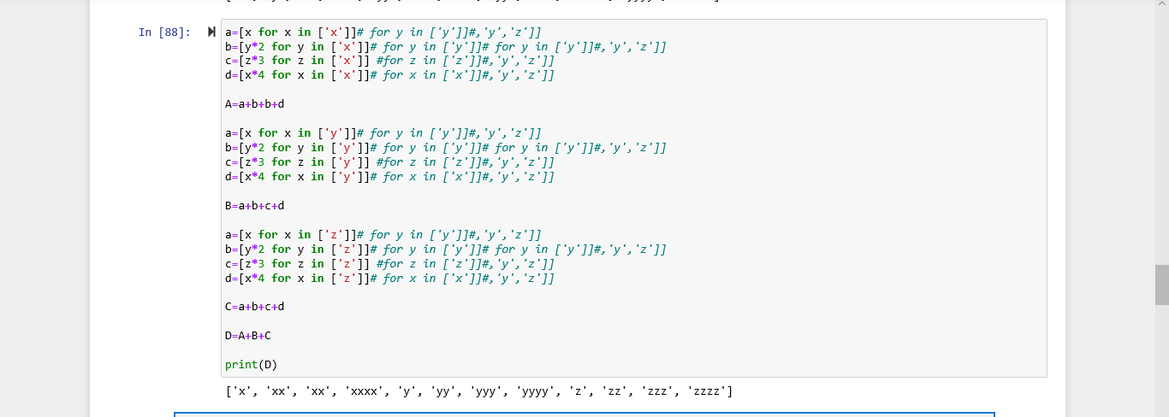
[‘x’,’y’,’z’,’xx’,’yy’,’zz’,’xx’,’yy’,’zz’,’xxxx’,’yyyy’,’zzzz’]
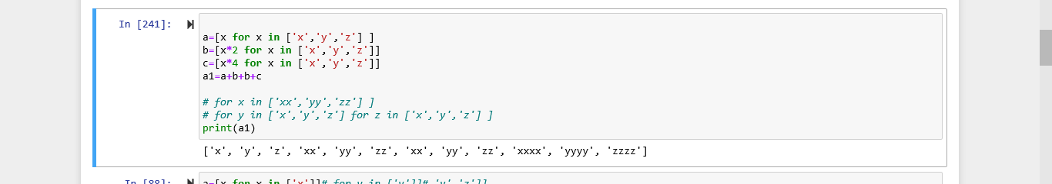
[[2],[3],[4],[3],[4],[5],[4],[5],[6]]
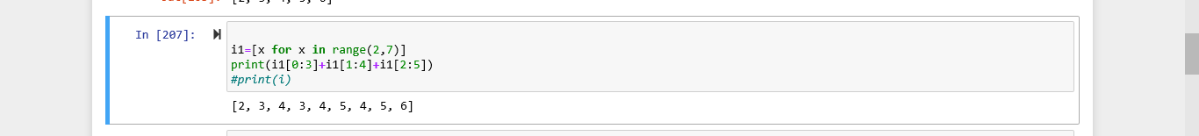
[[2,3,4,5],[3,4,5,6],[4,5,6,7],[5,6,7,8]]
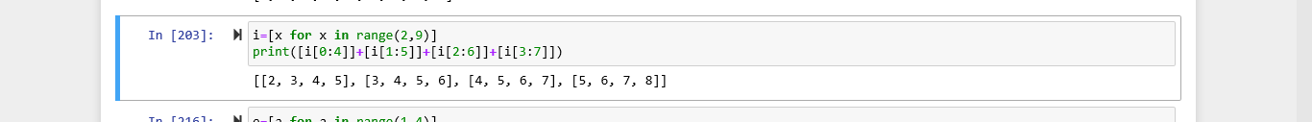

3.
Implement thefunction longestWord() that takes the list of words and return the longest one.
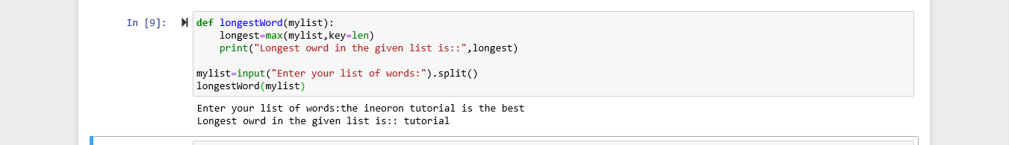

TASK 2:
1.1
Write a python program (with class concept) to find area of triangle.
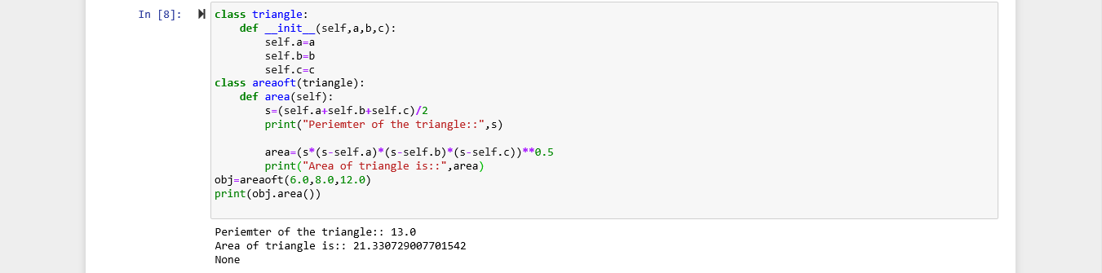
1.2
Write a function filter_long_words() that takes a list of words and an integer n and return the list of word that are longer than n.
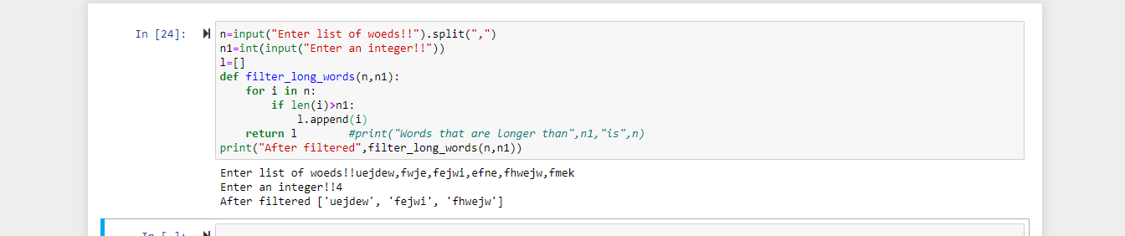

2.1
Write a python program using function concept that maps list of word into a list of integer representing the length of corresponding word.
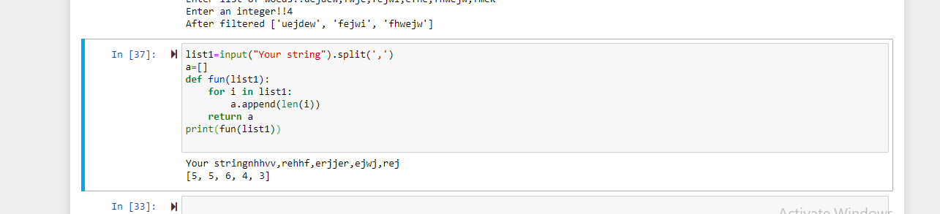

2.2
Write a python program which takes a character(that is the string of length 1) and return True if it is a vowel,False otherwise.
